https://www.gimp.org/features/:
GIMP Feature Overview (gimp.org)
GIMP is a versatile graphics manipulation package. This page should help you get a taste of what GIMP is capable of. You can also have a look at our introduction page or browse through the tutorials.

Customizable Interface
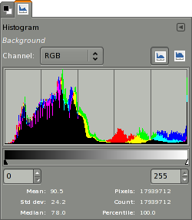
Each task requires a different environment and GIMP allows you to customize the view and behavior the way you like it. Starting from the widget theme, allowing you to change colors, widget spacings and icon sizes to custom tool sets in the toolbox. The interface is modulized into so called docks, allowing you to stack them into tabs or keep them open in their own window. Pressing the tab key will toggle them hidden.
GIMP features a great fullscreen mode allowing you to not only preview your artwork but also do editing work while using the most of your screen estate.

Photo Enhancement
Numerous digital photo imperfections can be easily compensated for using GIMP. Fix perspective distortion caused by lens tilt simply choosing the corrective mode in the transform tools. Eliminate lens’ barrel distortionand vignetting with a powerful filter but a simple interface.
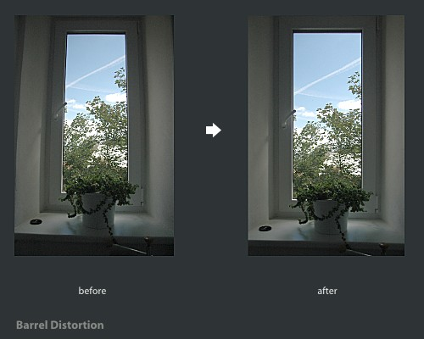
The included channel mixer gives you the flexibility and power to get your B/W photography stand out the way you need.
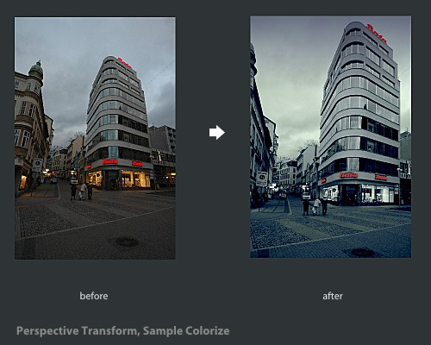

Digital Retouching
GIMP is ideal for advanced photo retouching techniques. Get rid of unneeded details using the clone tool, or touch up minor details easily with the new healing tool. With the perspective clone tool, it’s not difficult to clone objects with perspective in mind just as easily as with the orthogonal clone.

Hardware Support
GIMP includes a very unique support for various input devices out of the box. Pressure and tilt sensitive tablets, but also a wide range of USB or MIDI controllers. You can bind often-used actions to device events such as rotating a USB wheel or moving a MIDI controller’s slider. Change the size, angle or opacity of a brush while you paint, bind your favorite scripts to buttons. Speed up your workflow!
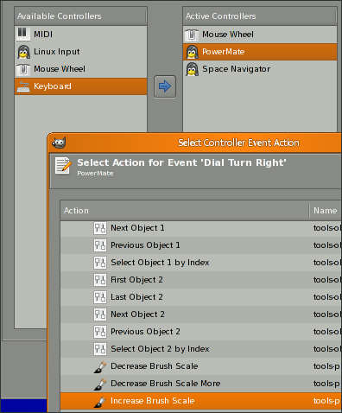

File Formats
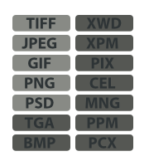
The file format support ranges from the common likes of JPEG (JFIF), GIF, PNG, TIFF to special use formats such as the multi-resolution and multi-color-depth Windows icon files. The architecture allows to extend GIMP’s format capabilities with a plug-in. You can find some rare format support in the GIMP plugin registry.
Thanks to the transparent virtual file system, it is possible to load and save files to from remote locations using protocols such as FTP, HTTP or even SMB (MS Windows shares) and SFTP/SSH.
To save disk space, any format can be saved with an archive extension such as ZIP, GZ or BZ2 and GIMP will transparently compress the file without you needing to do any extra steps.

Supported Platforms
- GNU/Linux
- Microsoft Windows (XP SP3, Vista, 7, 8)
- Mac OS X (10.6 and newer)
- Sun OpenSolaris
- FreeBSD

